When you click Fix IT button, the following appears:

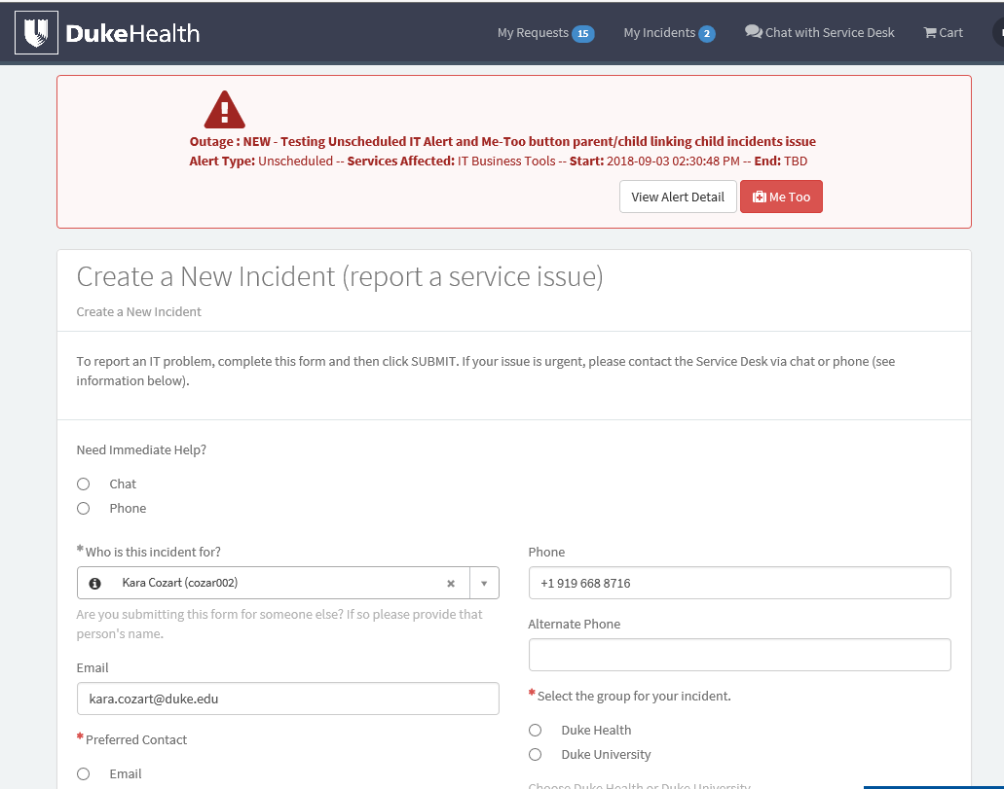When you Search on Fix IT, the following appears (completely different layout):

