Using Search, find RITM2155297:

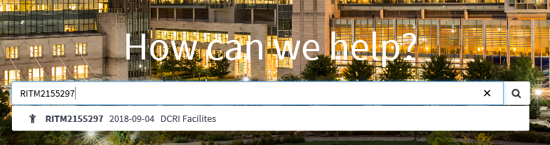

Result has activity on the left and a skinny column with all metadata on the right:

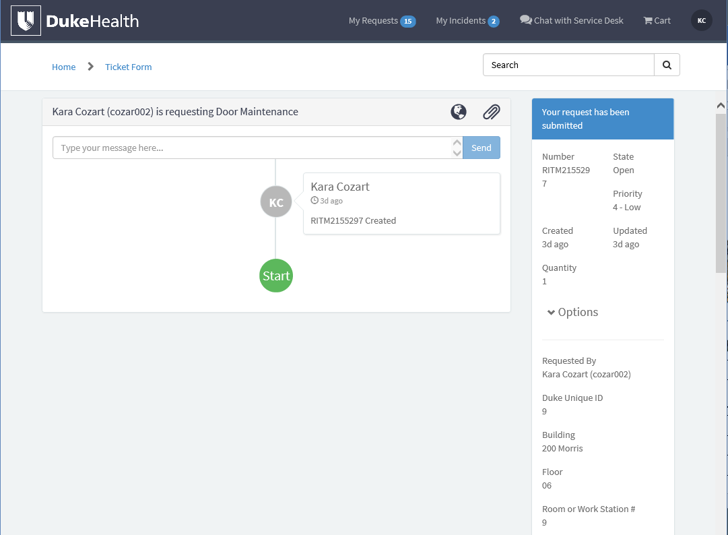

Using My Requests, find RITM2155297:

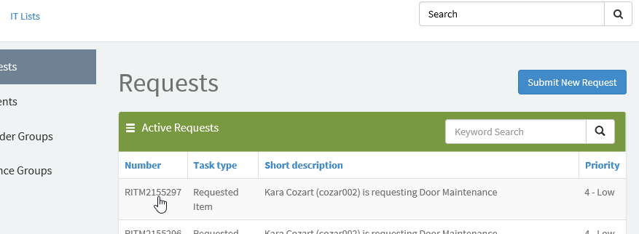

Result is a ticket view:

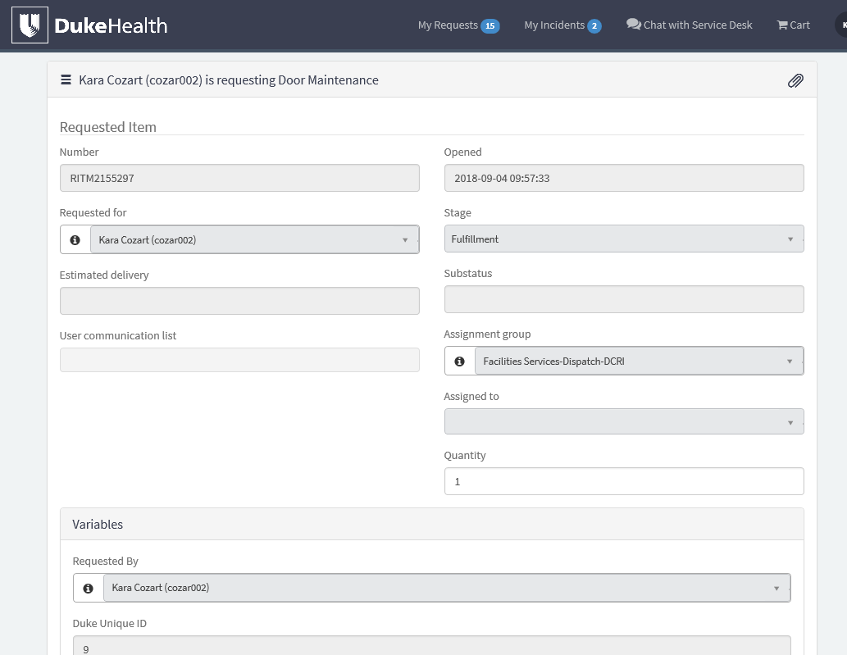

Shouldn’t the ticket view appear with both methods?